**Chapter 2 - CULTURAL FESTIVALS OF PAKISTAN: UNITY IN DIVERSITY**

**All Lectures Uploaded on YouTube:** [**https://tinyurl.com/fkm10-english**](https://tinyurl.com/fkm9-english)

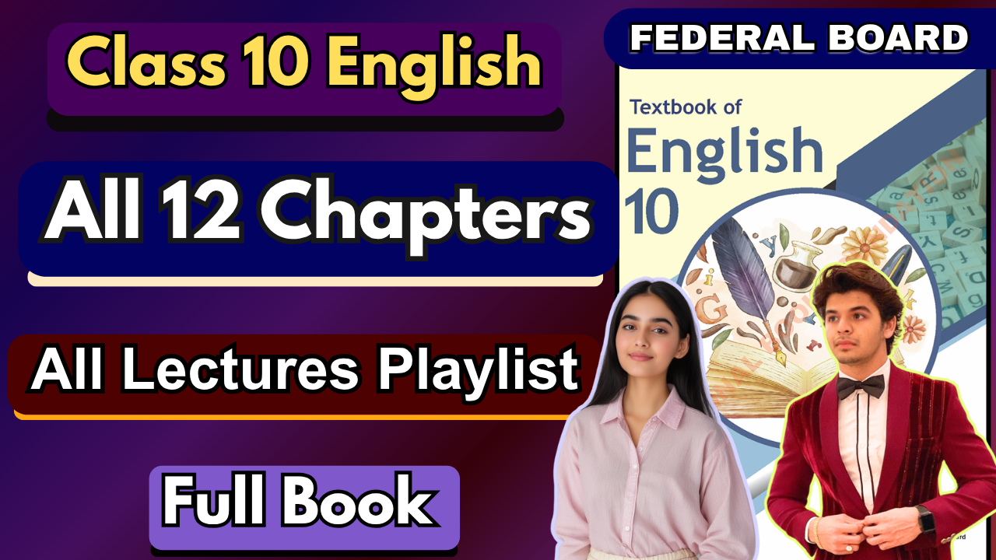

1. **Glossary:**

**Given below are the difficult words from the unit. Look at their meanings and use these words in your own sentences.**

| **Words** | **Meaning** |
| --- | --- |
| vibrant | full of energy and enthusiasm |
| bountiful | plentiful; abundant |
| fervently | with intense passion or emotion |
| socio-economic | relating to both social and economic factors |
| prominently | widely recognized or well-known |
| handicrafts | goods made by hand, often with artistic or traditional significance |
| congregations | gatherings of people for a specific purpose, often religious or social |
| diaspora | the dispersion of people from their original homeland |
| indigenous | native to a particular region or environment |
| pavilion | a large tent or building used for entertainment or public events |

The following are the sentences for the above mentioned words:

1. **Vibrant** – Lahore is known for its **vibrant** culture and lively streets.
2. **Bountiful** – The farmers were grateful for the **bountiful** harvest this year.
3. **Fervently** – She prayed **fervently** for her brother’s success in the exams.
4. **Socio-economic** – The government is working to reduce the **socio-economic** gap between the rich and poor.
5. **Prominently** – The national flag was displayed **prominently** at the entrance of the school.
6. **Handicrafts** – Pakistani **handicrafts** are famous worldwide for their intricate designs.
7. **Congregations** – Special **congregations** were held in mosques on Eid day.
8. **Diaspora** – The Pakistani **diaspora** contributes significantly to the country’s economy through remittances.
9. **Indigenous** – The Kalash people have preserved their **indigenous** traditions for centuries.
10. **Pavilion** – Each province set up a **pavilion** at the cultural exhibition to showcase its heritage.
11. **Reading and Critical Thinking Skills**

**A. Choose the correct answer:**

**i. What is the main activity during the Jashn e Baharaan festival?**

a) Traditional dance performances

b) Flower exhibitions

*c) Flying kites*

**ii. Where does the Shandur Polo Festival take place?**

a) Punjab

*b) Chitral*

c) Islamabad

**iii. Which ethnic group celebrates the Kalash Festival, and what does the festival symbolize?**

a) Baloch

*b) Kalash*

c) Sindhi

**iv. What is the primary focus of Sibi Mela in Balochistan?**

a) Traditional dances

*b) Livestock and handicrafts*

c) Literary gatherings

**v. How is Nowruz celebrated in Baltistan?**

a) Polo matches

*b) Distribution of coloured eggs*

c) Ploughing fields

**vi. When is Sindhi Cultural Day celebrated?**

*a) First Sunday of December*

b) First Sunday of January

c) Last Sunday of November

**vii. Who organizes the Lok Virsa Mela, and what does it celebrate?**

*a) National Institute of Folk and Traditional Heritage; Pakistan's diverse culture*

b) Ministry of Tourism; Folk music

c) Local communities; Religious traditions

**B. Read the unit carefully and answer the following questions.**

**i. Why is the Jashn-e-Baharaan celebration often referred to as the "Kite Festival" and what does it celebrate?**

**Ans.**

* It is called the "Kite Festival" because **kite flying is the central activity** of the celebration.
* It celebrates the **arrival of spring** and is seen as a joyful expression of culture and festivity.

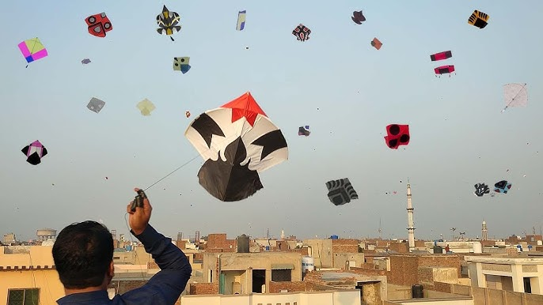

**ii. What customary events take place at the Shandur Polo Festival, and where is it held?**

**Ans.**

* The festival is held at Shandur Pass, Chitral.
* Events include polo matches, folk music, dances, and local cultural displays.

**iii. Explain the importance of the Kalash Festival and how it relates to the identity of the Kalash people.**

**Ans.**

* The Kalash Festival highlights the **unique culture, traditions, and religious practices** of the Kalash people.
* It strengthens their **sense of identity** and preserves their **distinct heritage** amidst Pakistan’s diverse culture.

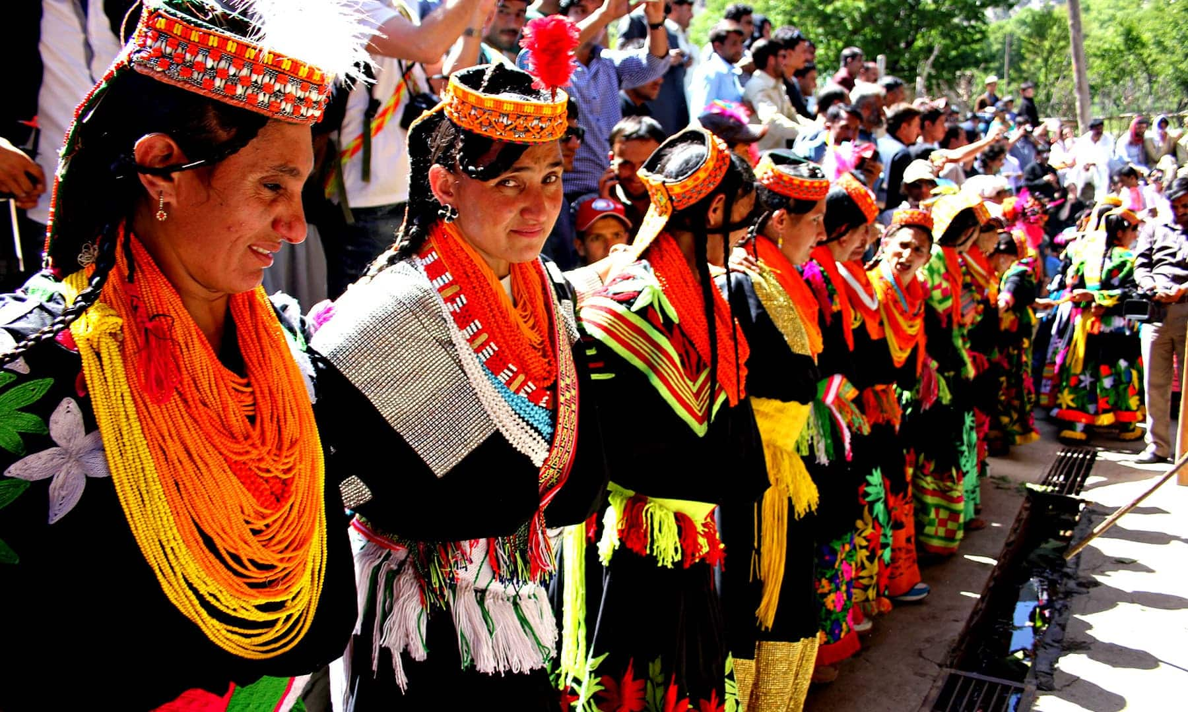

**iv. What is the role of Sibi Mela in Balochistan's cultural and economic landscape?**

**Ans.**

* It plays a vital role in showcasing **livestock, handicrafts, and local traditions**.
* The mela boosts the **economy** of the region through trade while promoting **Baloch culture and heritage**.

**V. Describe the cultural significance of Nowruz in Baltistan, Hunza, Chitral, and Gilgit.**

**Ans.**

* Nowruz marks the **Persian New Year** and is celebrated at the start of spring.
* Customs include **ploughing fields** for a good harvest, **distribution of colored eggs**, and various **festive gatherings**, reflecting joy and renewal of life.

**vi. What events are usually scheduled on Sindhi Cultural Day, and why is it celebrated by Sindhis?** 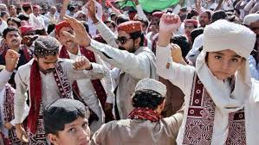

**Ans.**

* Events include **traditional dances, music, rallies, and wearing of Sindhi Ajrak and Topi**.
* It is celebrated to **honor and preserve Sindhi heritage and pride**, highlighting unity in their cultural identity.

**vii. How does the Lok Virsa Mela add to the celebration of Pakistan's rich cultural diversity?**

**Ans.**

* Organized by the **National Institute of Folk and Traditional Heritage**, it brings together folk **artists, musicians, craftsmen, and performers** from all provinces.
* It showcases Pakistan’s **rich cultural mosaic**, fostering **unity in diversity** and preserving traditions for future generations.

1. **Vocabulary and Grammar**

**Common Roots To Make New Words**

Common roots are fundamental building blocks of words, often derived from **ancient Greek** or **Latin**. These roots carry specific meanings that, when combined with **prefixes** (added to the beginning) and **suffixes** (added to the end), create new words with related meanings. Understanding these roots can significantly expand your vocabulary and help you decipher the meanings of unfamiliar words.

### **Examples of Common Roots**

Here are some common roots, along with examples of words they form and the meaning of those words.

#### **1. -'bio'**

This root comes from the Greek word *'bios'*, meaning **'life'**.

* **Biology:** The study of **life**.
* **Biography:** A written account of a person's **life**.
* **Antibiotic:** A substance that destroys or inhibits the growth of microorganisms, thus fighting **life** (specifically, bacterial life).

#### **2. -'auto'**

This root is from the Greek word *'autos'*, meaning **'self'**.

* **Autobiography:** The story of one's **own** life
* **Autograph:** A person's **own** signature
* **Automatic:** A device or process that works by **itself**.

#### **3. -'phon'**

This root originates from the Greek word *'phōnē'*, which means **'sound'** or **'voice'**.

* **Telephone:** A device used to transmit **sound** over a distance.
* **Symphony:** A complex musical composition with different instruments creating a harmonious **sound** together.
* **Phonics:** A method of teaching reading by correlating **sounds** with letters or groups of letters.

#### **4. -'graph'**

This root comes from the Greek word *'graphein'*, meaning **'to write'** or **'to draw'**.

* **Autograph:** A person's signature, **written** by themselves
* **Graphite:** A soft carbon mineral used as the **writing** part of a pencil.
* **Calligraphy:** The art of beautiful **writing**.

#### **5. -'man'**

This root is from the Latin word *'manus'*, meaning **'hand'**

* **Manual:** Something done by **hand**, or a handbook that you hold in your **hand**.
* **Manufacture:** To make something, originally by **hand**.
* **Maneuver:** To move or guide something with your **hands**.

#### **6. -'scope'**

This root is from the Greek word *'skopein'*, meaning **'to see'** or **'to look'**.

* **Microscope:** An instrument used to **see** very small objects.
* **Telescope:** An instrument used to **see** distant objects.
* **Periscope:** An optical instrument used to **see** things from a concealed position.

**Q: Use the roots given below to make three different words. Also give meaning of the root and the words formed using that root.**

**Ans.**

1. **Bio- (life)**

* Biology → study of life
* Biography → life story of a person
* Biodegradable → capable of being decomposed by living organisms

1. **Graph- (writing/drawing)**

* Autograph → a person’s handwritten signature
* Paragraph → a section of writing
* Graphic → relating to visual art or written/drawn representation

1. **Geo- (earth)**

* Geography → study of the earth’s surface
* Geology → study of the structure of the earth
* Geothermal → heat energy from the earth

1. **Mega- (large/great)**

* Megaphone → device to amplify sound
* Megabyte → unit of digital information (large amount of data)
* Megacity → very large city

1. **Hydro- (water)**

* Hydroelectric → producing electricity using water
* Hydrology → study of water
* Hydroplane → a vehicle that glides on water

**B. Complete each sentence by turning the given verb into a noun using an appropriate suffix. Choose from the following suffixes: -tion, -ment, -ance, -ence, -ing.**

**annoy, educate, compile, maintain, announce, communicate, discuss, complete**

i. The act of teaching is called **education**.  
 ii. Her constant complaining is becoming a real **annoyance**.  
 iii. The manager's **announcement** of the new policy was well-received.  
 iv. The **compilation** of the data took longer than expected.  
 v. The team celebrated the **completion** of their project with a party.  
 vi. The **maintenance** of the car is getting very expensive.  
 vii. Effective **communication** is essential for a clear message.  
 viii. The **discussion** on the issue has been postponed till the next meeting.

**Collective Nouns**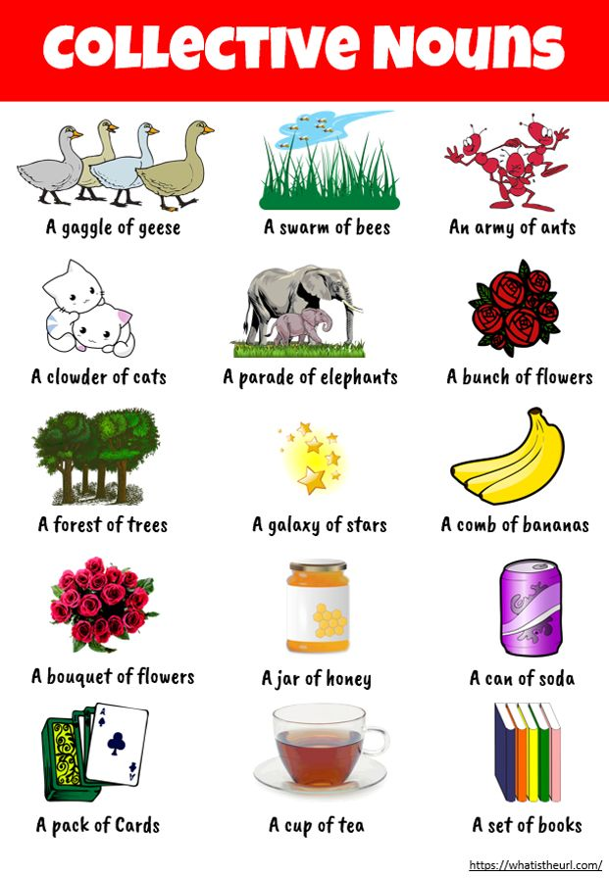

A **collective noun** is a word that refers to a **group of people, animals, or things** considered as a **single unit**.  
Even though the group may consist of many individuals, it is treated as **one entity** when spoken about collectively.

For example:

* *class* = a group of students
* *herd* = a group of cattle
* *team* = a group of players

**D. Practice Exercise:**

**Fill in the blanks with the appropriate collective noun.**

i. The **class** is planning a surprise party for our teacher.

ii. A **flock** of sheep was peacefully grazing in the field.

iii. Our **team** won the championship last year.

iv. A **flock** of geese flew overhead, heading south for the winter.

v. The school **committee** is organizing a charity event.

vi. We encountered a **school** of fish while snorkeling in the coral reef.

vii. The **troupe** of actors rehearsed tirelessly for the upcoming play.

viii. A **colony** of ants was busy carrying food to their nest.

**E. Present Indefinite Tense**

**(Also called Simple Present Tense)**

The Present Indefinite Tense expresses actions that are:

* habitual or regular
* general truths or facts
* universal statements
* feelings, thoughts, and permanent situations

It is the most commonly used tense in English for describing daily routines, habits, and facts.

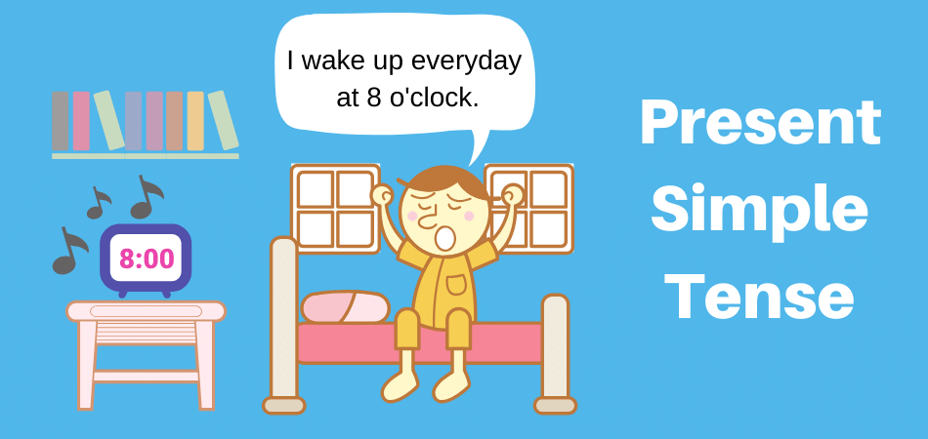

## 

## **Structures of Present Indefinite Tense**

### **1. Affirmative Sentences**

**Structure:**

* Subject + Base Verb (1st form) + Object
* If subject = *he, she, it* → add **s/es** to the verb.

**Examples:**

* I play cricket every weekend.
* She reads books daily.
* The sun rises in the east.
* They go to school by bus.

### **2. Negative Sentences**

**Structure:**

* Subject + Do/Does + Not + Base Verb + Object
* Use **do not (don’t)** with *I, we, you, they*.
* Use **does not (doesn’t)** with *he, she, it*.

**Examples:**

* I do not like coffee.
* He does not play football.
* They do not watch TV at night.
* She doesn’t go to the market every day.

### **3. Interrogative Sentences**

**Structure:**

* Do/Does + Subject + Base Verb + Object + ?

**Examples:**

* Do you speak English?
* Does she know the answer?
* Do they go to school on Fridays?
* Does Ali live in Lahore?

## **When Do We Use the Present Indefinite Tense?**

1. **Habitual/Repeated Actions**
   * She brushes her teeth twice a day.
   * I go to school daily.
2. **Universal Truths/Scientific Facts**
   * The earth revolves around the sun.
   * Water boils at 100°C.
3. **Fixed Arrangements (timetables, schedules)**
   * The train leaves at 6 p.m.
   * My class starts at 8 a.m.
4. **Feelings, Emotions, or States**
   * I love my parents.
   * He believes in honesty.

**Practice Exercise:**

**Fill in the blanks with the correct form of the verbs in the present indefinite tense:**

Once a week, Suniya **goes** to the gym. She **likes** to stay fit. She usually **exercises** for about an hour. After the workout, she **eats** a healthy snack. Sarah **believes** that regular exercise **improves** both physical and mental well-being.

**F. Present Continuous Tense**

The **Present Continuous Tense** (also called Present Progressive) expresses actions that are:

* happening **right now** at the moment of speaking
* temporary actions
* near future plans or arrangements

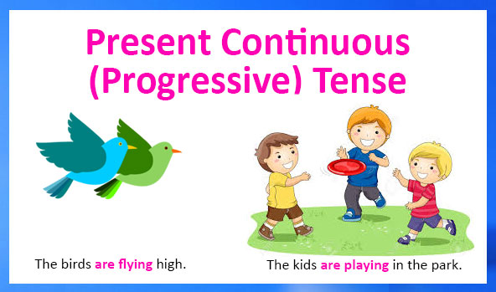

### **Structure**

**Affirmative:** Subject + is/are/am + Verb(ing) + Object

**Examples:**

* I **am studying** for my exam.
* She **is reading** a novel.
* They **are playing** football.

**Negative:** Subject + is/are/am + not + Verb(ing) + Object

**Examples:**

* I **am not eating** dinner right now.
* He **is not working** on the project.
* We **are not going** to the park today.

**Interrogative:** Is/Are/Am + Subject + Verb(ing) + Object + ?

**Examples:**

* **Am I speaking** too fast?
* **Is she watching** TV?
* **Are they coming** to the part

**Q: Fill in the blanks with the correct form of the verbs in the present continuous tense.**

Shahzeb and his brother **are studying** for their exams. The clock **is ticking** loudly, and the rain **is falling** gently outside. Shahzeb's cat **is sleeping** on the sofa, and the smell of dinner **is filling** the air. Shahzeb's phone **is ringing**, and he **is answering** it quickly. It's his friend inviting him to a party.

**G. Modal verbs: (Must/Must not)**

**Modal verbs** are special auxiliary verbs that express ability, possibility, permission, necessity, or obligation.

They are always followed by the **base form of the verb** (without *to*).

### **Structures**

**Affirmative:** Subject + Modal + Base Verb + Object

**Examples:**

* She **can speak** English.
* You **must finish** your homework.
* They **will play** cricket tomorrow.

**Negative:** Subject + Modal + Not + Base Verb + Object

**Examples:**

* He **cannot drive** a car.
* We **should not waste** water.
* You **must not tell** lies.

**Interrogative:** Modal + Subject + Base Verb + Object + ?

**Examples:**

* **Can you help** me?
* **Should I call** him now?
* **Will they attend** the meeting?

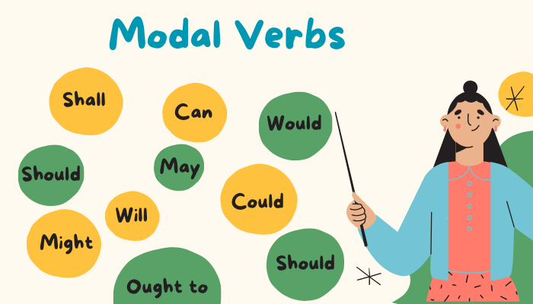

**H. Fill in the blanks with the correct form of "must"or "must not" based on the context.**

Students, you **must bring** your textbooks to class every day. You **must not forget** to do so. Also, you **must not talk** during the lecture. It **must not disturb** others. Remember, you **must submit** your assignments by Friday. You **must get** it signed by your teacher before the 20th of this month.

**I. Punctuation Marks:**



